**DAILY ONLINE ACTIVITIES SUMMARY**

|  |  |  |  |  |  |  |  |  |
| --- | --- | --- | --- | --- | --- | --- | --- | --- |
| **Date:** | **22/06/2020** | | | | | **Name:** | **Lavanya D M** | |
| **Sem & Sec** | **4th & ‘A’** | | | | | **USN:** | **4al18cs041** | |
| **Online Test Summary** | | | | | | | | |
| **Subject** | | **nil** | | | | | | |
| **Max. Marks** | | **nil** | | **Score** | | | **nil** | |
| **Certification Course Summary** | | | | | | | | |
| **Course** | **Creating blog** | | | | | | | |
| **Certificate Provider** | | | **Bitdegree** | | **Duration** | | | **1week** |
| **Coding Challenges** | | | | | | | | |
| **Problem Statement:**  1) Write a Java Program for Modular Exponentiation  2) Write a java program to find the leap year or not | | | | | | | | |
| **Status: complied** | | | | | | | | |
| **Uploaded the report in Github** | | | | | **yes** | | | |
| **If yes Repository name** | | | | | <https://github.com/lavanyamurthi/lockdown-coding> | | | |
| **Uploaded the report in slack** | | | | | **yes** | | | |

Online Test Details: (Attach the snapshot and briefly write the report for the same)

No test conducted

**Webinar:**

Today webinar call is conducted on IOT by Sushanth sir in which we learn about the IOT concept

Certification Course Details: (Attach the snapshot and briefly write the report for the same)

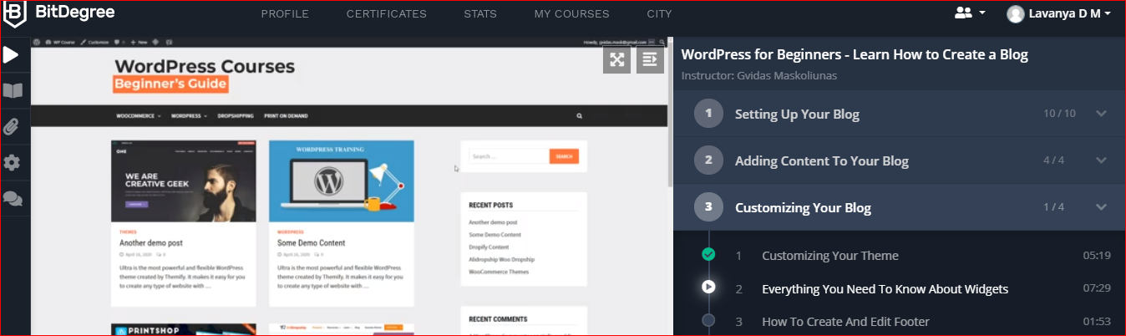

Coding Challenges Details: (Attach the snapshot and briefly write the report for the same)

**Problem 1** : Write a Java Program for Modular Exponentiation

Given three numbers x, y and p, compute (xy) % p.  
Input: x = 2, y = 3, p = 5  
Output: 3  
Explanation: 2^3 % 5 = 8 % 5 = 3.

Input: x = 2, y = 5, p = 13  
Output: 6  
Explanation: 2^5 % 13 = 32 % 13 = 6.

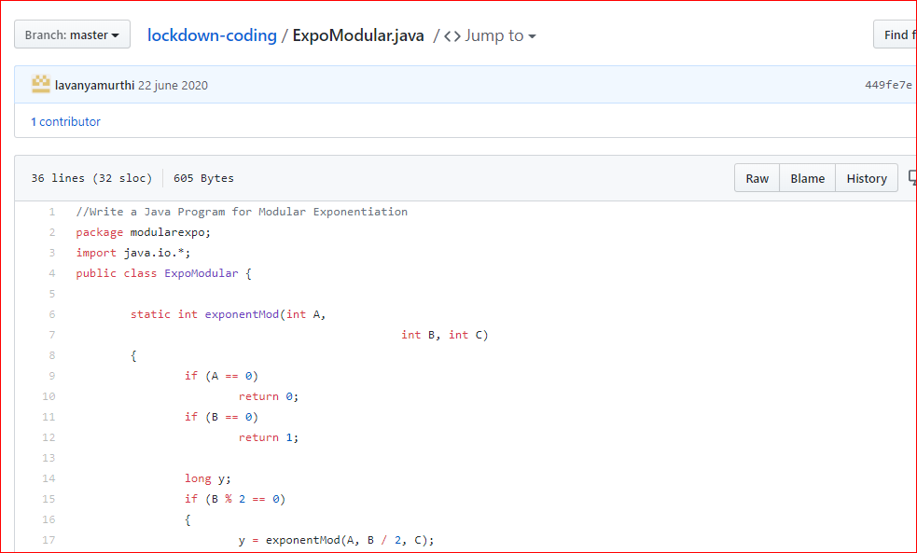

**Problem 2:** Write a java program to find the leap year or not

